**Visit Georgia**

Georgia is one of the most beautiful and ancient countries in the world with a unique cultural and historical background. A hospitality of high-spirited cultured people in Georgia is well known among guests. It is truly a marvelous canvas for walkers, horse riders, cyclists, skiers, rafters and travelers of every kind, so it has become a special destination for tourists from all of the world. The purpose of the Visit Georgia website is to display to a user the most featured landmarks, activities, tours, restaurants and accommodations for tourists in Georgia.

The Visit Georgia project will contain total 4 linked html documents: home page, things to do (activities) in Georgia, tours and other related services, such as markets, restaurant and hotels. The home page will be a branding showcase displaying the most stunning images of Georgia through a Javascript empowered slideshow, including a brief description about historical, cultural, social and natural landmarks of Georgia for tourists. The home page will include also a responsive row of 3 images that will signify the most popular attraction features of Georgia: the most popular place to visit, the most exciting activity to do and the most favorite food/drink example (most likely, wine). The remaining pages will display the list of the most popular Georgian landmarks, tours, restaurants and hotels based upon online websites and feedbacks from tourists and guests. Each page will have a navigation bar and footer. The navigation bar will have a logo and will navigate a user to the local html files. The footer will contain links to local html files and icons to external social media sources related to tourism in Georgia.

The following wireframe diagrams display mockups for each webpage respectively: (1) Home Page; (2) Things To Do; (3) Tours; (4) Other Services. Note that responsive Bootstrap rows for activities, tours, accommodations and restaurants could be updated or new ones added later. The map and weather widgets could be also added to the footer in the Home page as additional features.

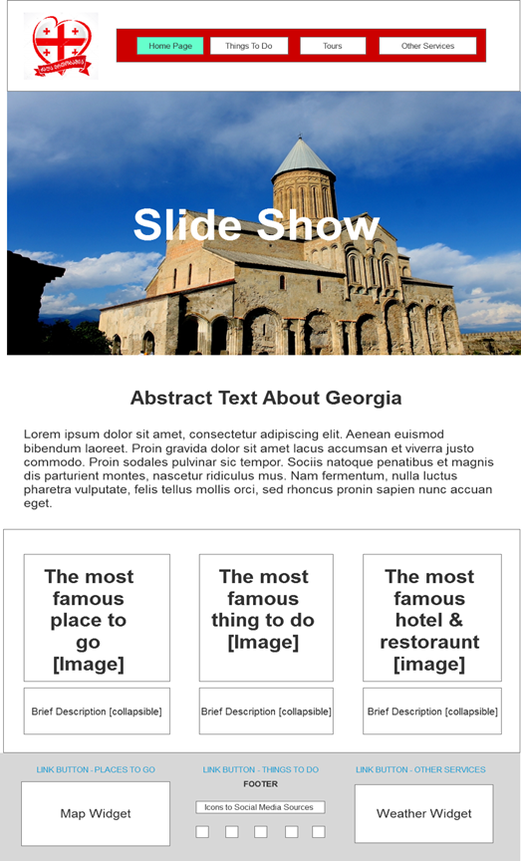

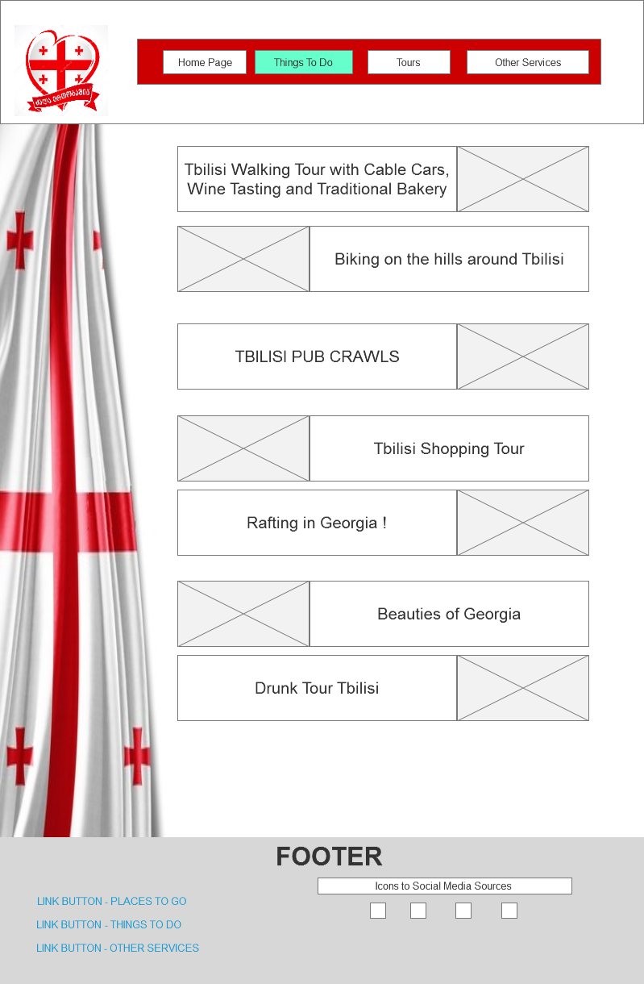

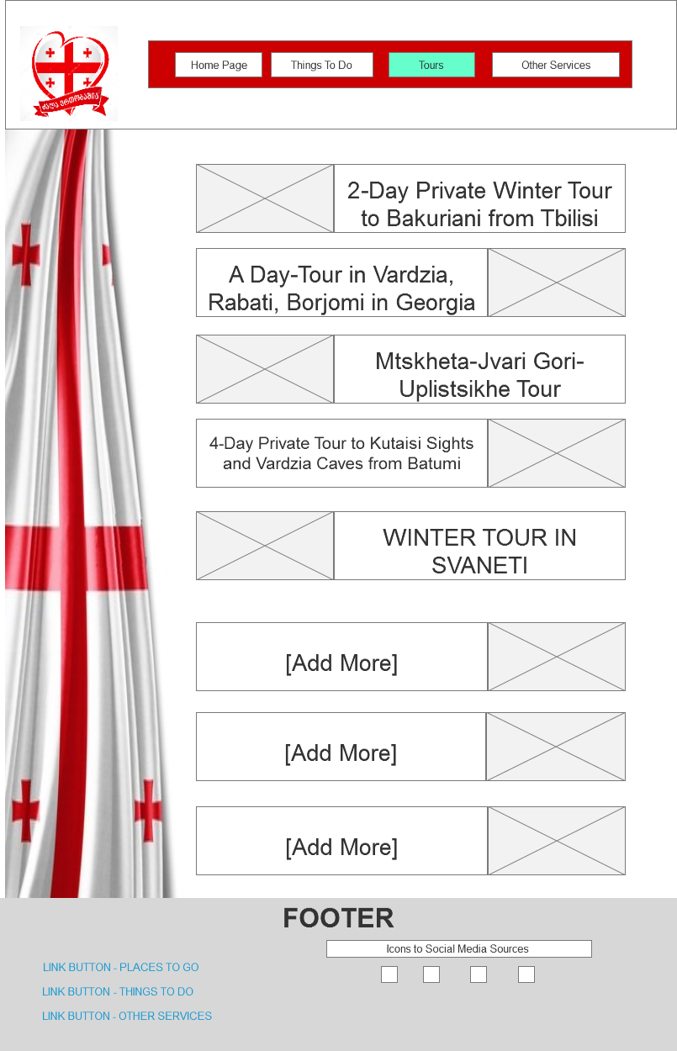

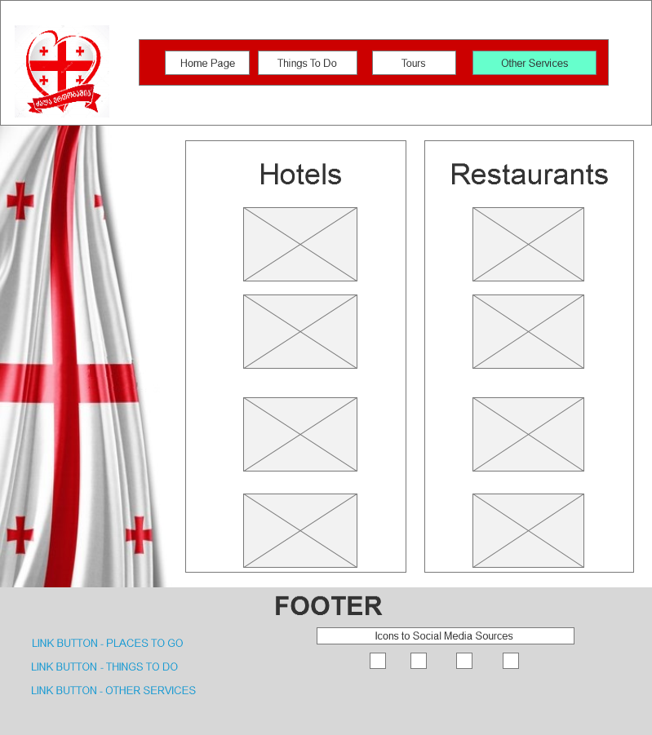

[**https://www.tripadvisor.com/Attractions-g294194-Activities-Georgia.html**](https://www.tripadvisor.com/Attractions-g294194-Activities-Georgia.html)

[**https://www.gotravelyourway.com/2013/11/12/8-reasons-to-travel-to-georgia-and-tbilisi/**](https://www.gotravelyourway.com/2013/11/12/8-reasons-to-travel-to-georgia-and-tbilisi/)

[**https://www.lonelyplanet.com/georgia**](https://www.lonelyplanet.com/georgia)

[**https://hippie-inheels.com/should-not-miss-country-of-georgia/**](https://hippie-inheels.com/should-not-miss-country-of-georgia/)